**Soal**

*Case*

**Singapore**

**Singapore** is an island city-state off southern Malaysia**.** It is known as a global financial center with a tropical climate and multicultural population. You are required to create the **geographical features** and **data** for **Singapore** by designating its **park** **area**, **roads**, **places, and other details** using the **ArcMap** **application**. **Base map** and **Coordinate System** already provided by Geographical Designer.

* First, view the assigned area by following the steps below:
  + Open **ArcMap** and create a new **Geodatabase**.
  + Open the **.png** grid map file that has been given using the **ArcMap**.

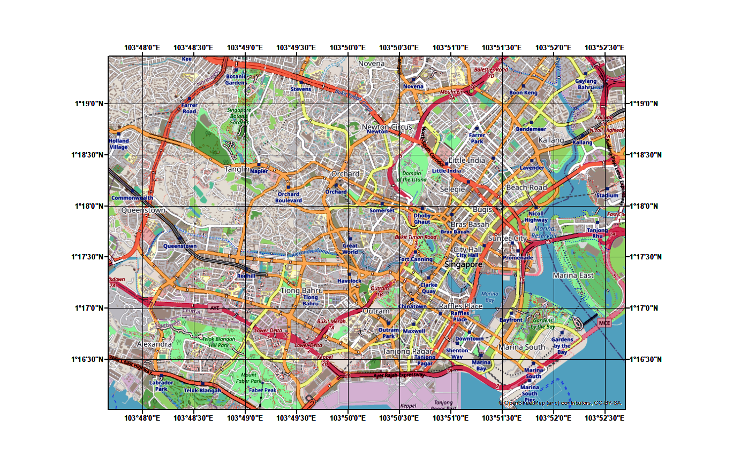

**Figure 1. Grid Map**

* + **Georeferenced** the **grid image** based on the coordinate and **rectify the image**.
  + Open the **.png** section map file that has been given using the **ArcMap**.

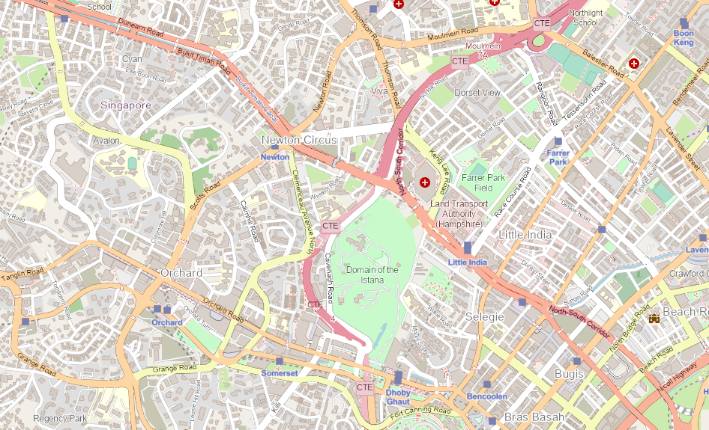

**Figure 2. Section Map**

* + **Georeferenced** the **section map** based on **the grid map** and **rectify the image**.

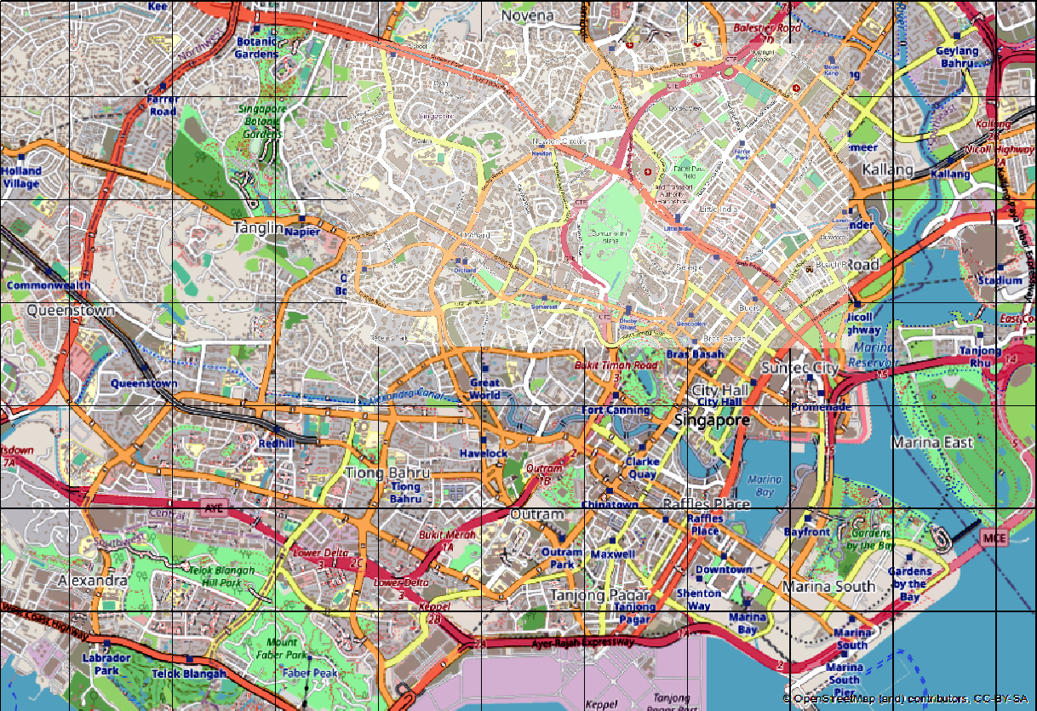

**Figure 3. Image after Rectify**

* Create a **geodatabase** with the following feature classes:
  + - **Polygon** **feature** that shows at **least 3 parks** in the map with the following attributes:

|  |  |  |  |
| --- | --- | --- | --- |
| **Field Name** | **Data Type** | **Length** | **Notes** |
| Name | Text / String | 50 | Input manually.  **Example**: ‘Orchard Park’ |
| MaxPeople | Long Integer | **-** | **Calculated Field:**  It must be filled with the round up value of the area divided by 8 m2. |
| EntrancePrice | Text | 50 | **Calculated Field:**  It must be filled with the round up value of the square root **SHAPE_Length** and added with **‘$’** in front of the price.  **Example:** if the *SHAPE_Length* is **570.935891** then the result is: **‘$23’** |

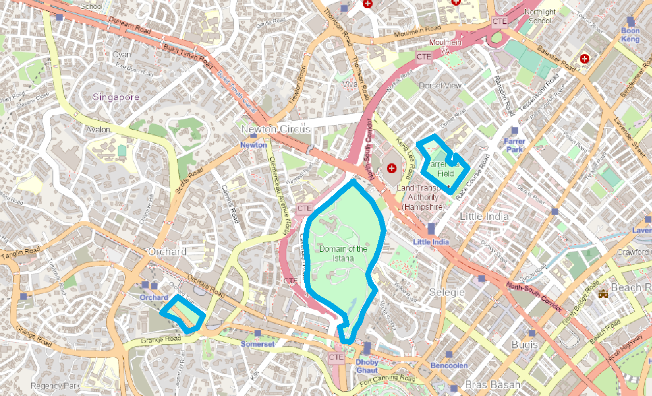

**Figure 2. Example polygon feature**

* + - **Line** **feature** that shows at **least 15 roads** in the map and the following attributes:

|  |  |  |  |
| --- | --- | --- | --- |
| **Field Name** | **Data Type** | **Length** | **Notes** |
| Name | Text / String | 50 | Input manually.  **Example: ‘Light Close’** |
| ID | Text / String | 5 | **Calculated Field:**  The **uppercase** of 4 **first** **characters** of ‘**Name**’ added with **last** **characters** of ‘**Object_ID’**.  **Example:** if the *Name* is **Light Close** and the *Object_ID* is **14** then the r*esult* will be ‘**LIGH4’**. |
| Type | Text / String | 50 | Input manually either ‘**Boulevard** or ‘**Alley**’.  **Example: ‘Alley’** |
| Status | Text / String | 50 | Input manually either ‘**Free** or ‘**Pay**’.  **Example: ‘Free’** |
| MaxCar | Text / String | 50 | **Calculated Field:**  The roundup value of ‘**SHAPE_Length**’ divided with 6 and added with  ‘ **Car(s)**’  **Example**: if the *SHAPE_Length is* **369.601462**, then the *result* is: ’**61 Car(s)**’. |

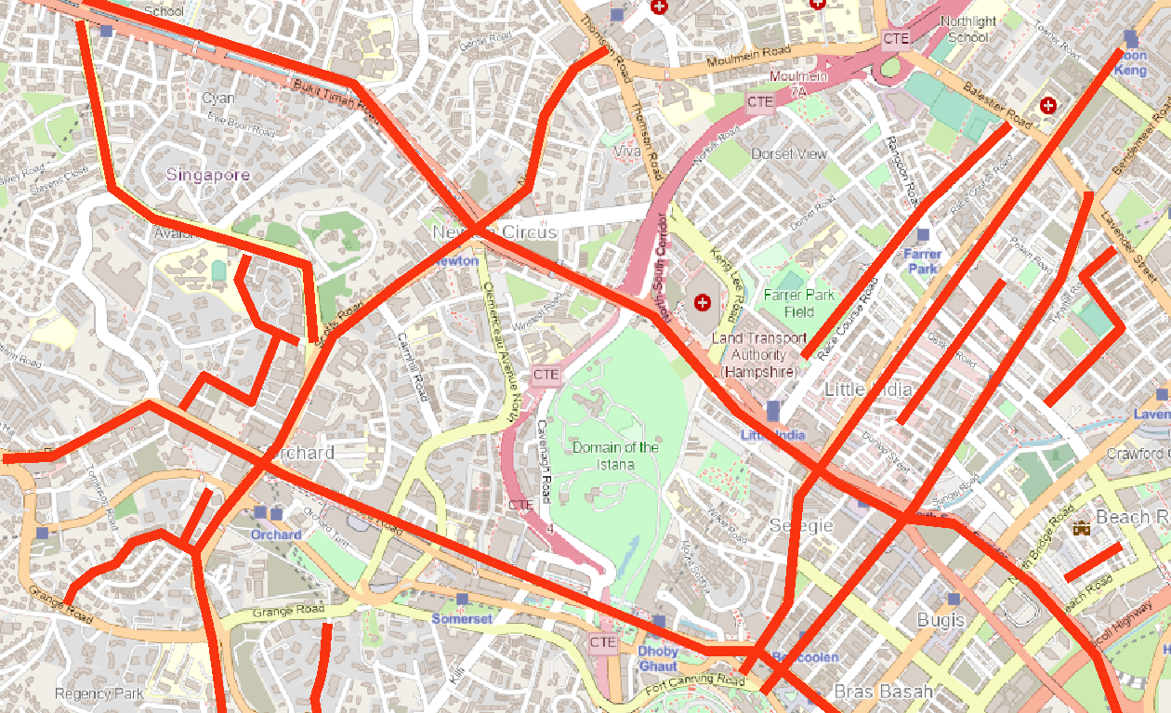**Figure 3. Example line feature**

* + - **Point feature** that shows **at least 20 places** on the map with the following attributes:

|  |  |  |  |
| --- | --- | --- | --- |
| **Field Name** | **Data Type** | **Length** | **Notes** |
| Name | Text / String | 50 | Input manually and contains two words.  **Example: ‘North Son’** |
| Type | Text/ String | 10 | Input manually either ‘**Hospital**, ‘**Mall’** or ‘**School**’. **Example: ‘Hospital’** |
| Alias | Text/ String | 50 | **Calculate Field:**  Get the first word of **Name** field.  **Example:** if the *Name* is **North Son,** then the *result* is : ‘**North**’ (without quotes) |
| Status | Text/ String | 7 | Input manually either ‘**Private** or ‘**Public**’. **Example:** ‘**Private**’ |

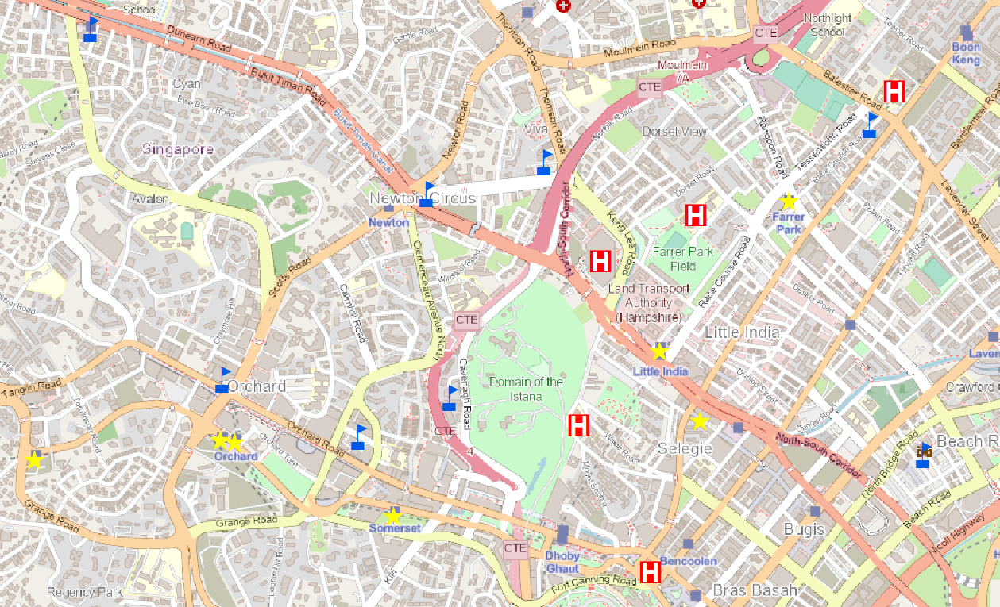

**Figure 4. Example point feature**

**Change the points of places symbol** using **symbology** categorized based on the “**Type**” field. Each category of type has its own unique symbol which are:

|  |  |  |
| --- | --- | --- |
| **Type** | **Symbol** | **Description** |
| Hospital |  | * Symbol Hospital 2 * Mars Red * Size 30 |
| Mall |  | * Symbol Star 1 * Solar Yellow * Size 35 |
| School |  | * Symbol School 3 * Lapis Lazuli * Size 35 |

* Create **selections** with below requirements:
  + Create a layer that can **select all parks** where the **MaxPeople** is **greater than 200.** Please make sure the selected feature is **imported** into your **.gdb file.**

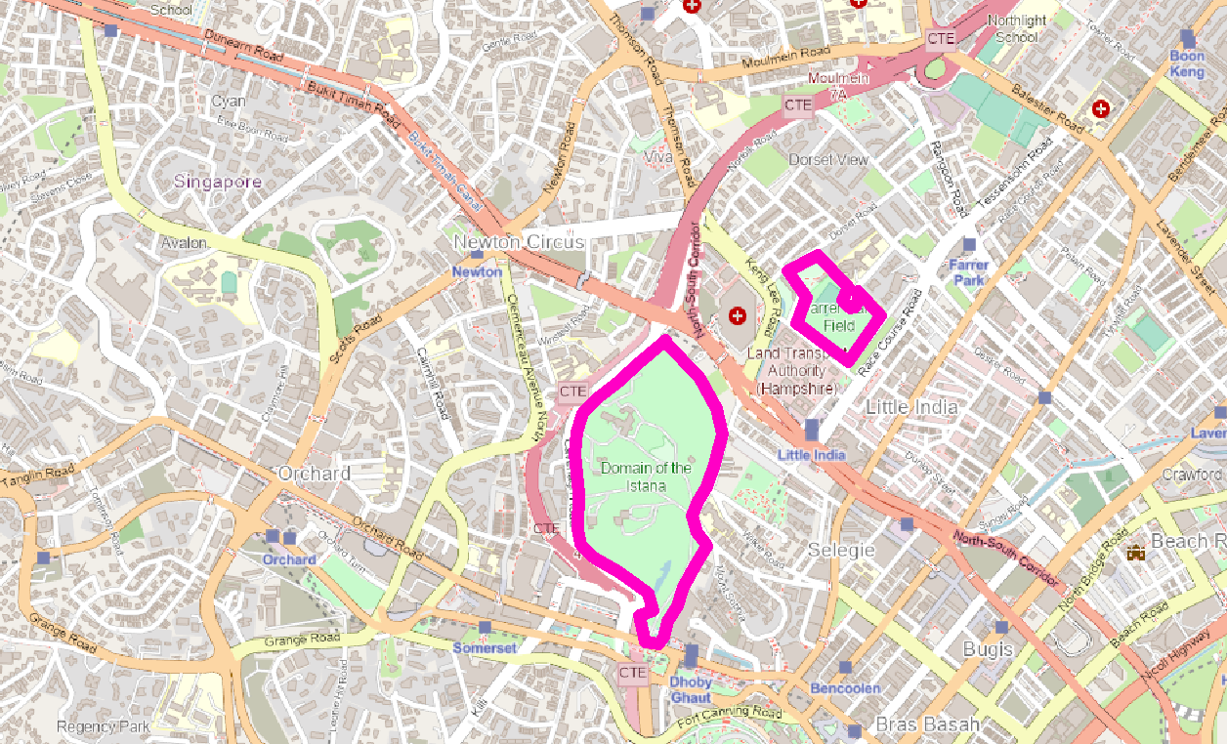

**Figure 5. Example of polygons of parks selection layer**

* + Create a layer that can **select all points of places** where the **name starts with** ‘**Grand** ’. Please make sure the selected feature is **imported** into your **.gdb** **file**.

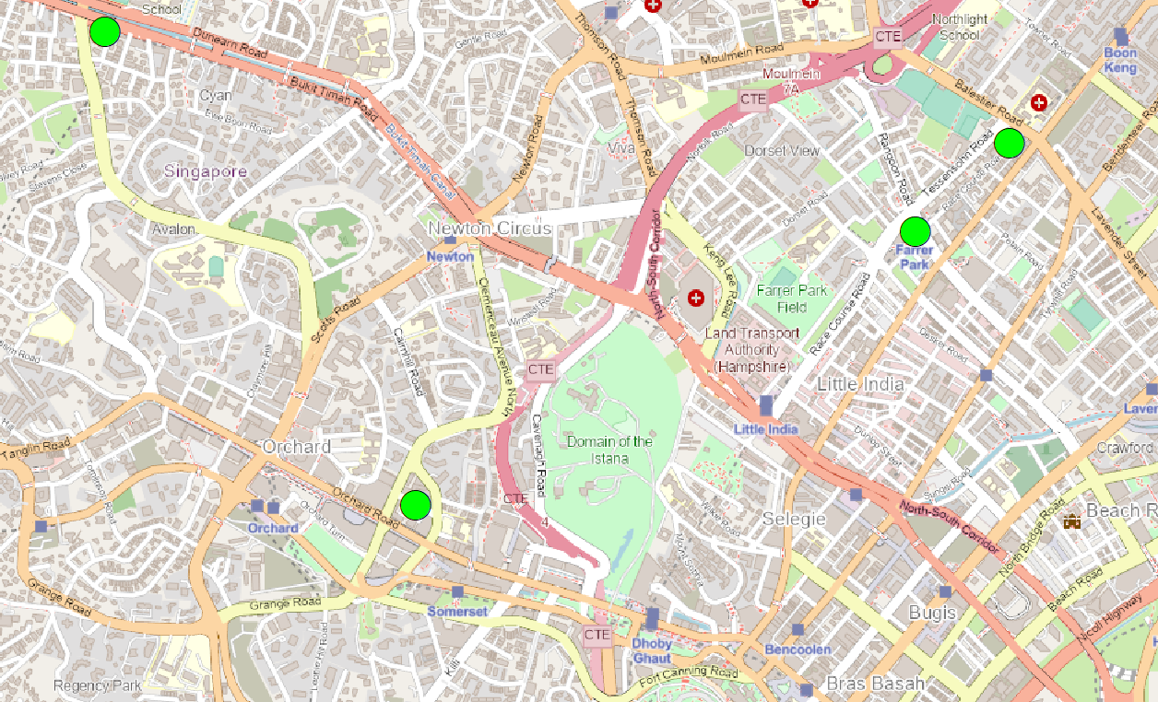

**Figure 5. Example of points of places selection layer**

* + Create a layer that can **select all points of places** where the **Status** is **equal** **to** ‘**Public**’ and **Type** is **equal** **to** ‘**Hospital**’ (without quotation). Please make sure the selected feature is **imported** into your **.gdb** **file**.

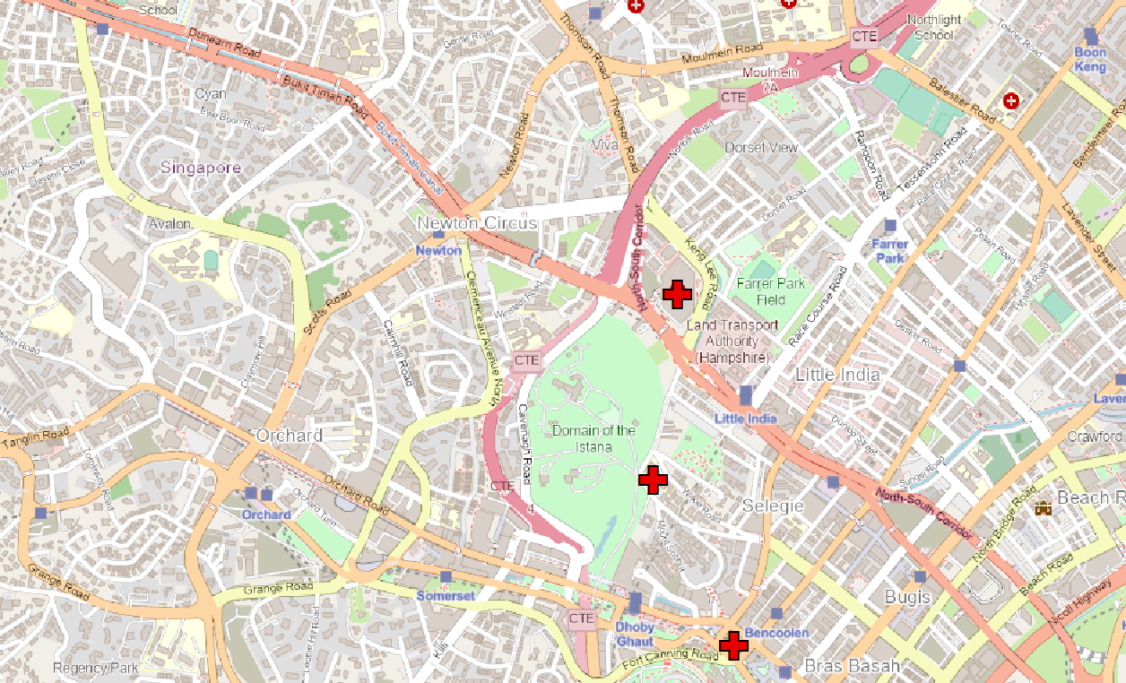

**Figure 6. Example of points of places selection layer**

* + Create a layer that can **select roads** where the **SHAPE_Length** is **more than** or **equal** **to** the average of all **SHAPE_Length**. Please make sure the selected feature is **imported** into your **.gdb** **file**.

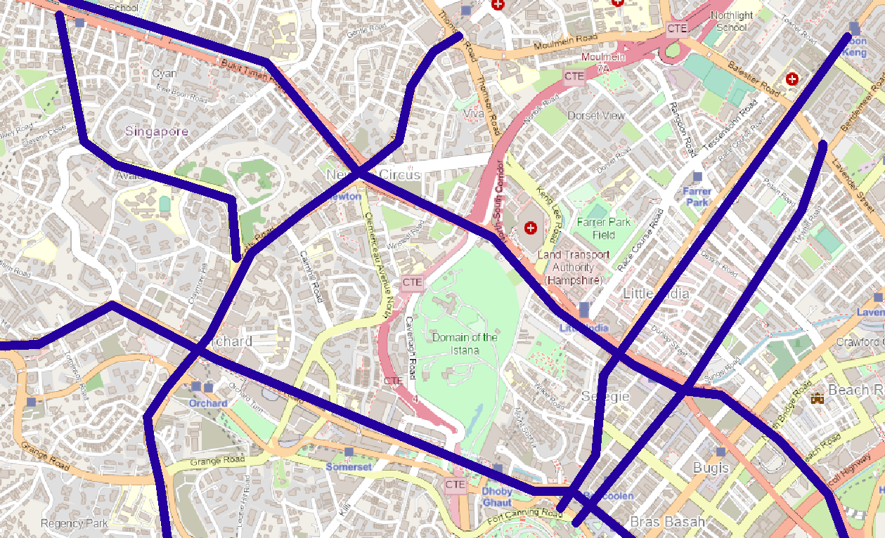

**Figure 6. Example of roads selection layer**

* Create **buffers** with below requirements:
  + Create a buffer for **places** that expand the size of the place by **15** m.

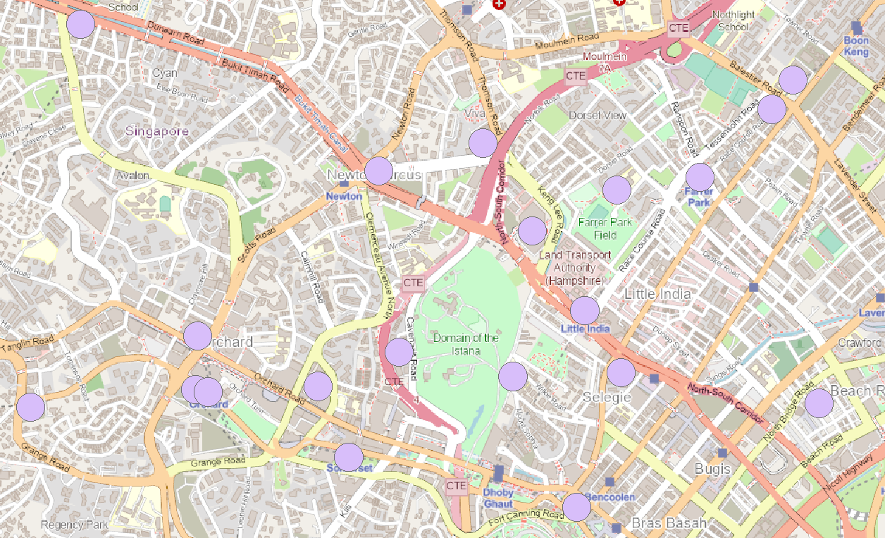

**Figure 7. Example of places buffer**

* + Create a buffer for **roads** that widen the road’s width by **10** m.

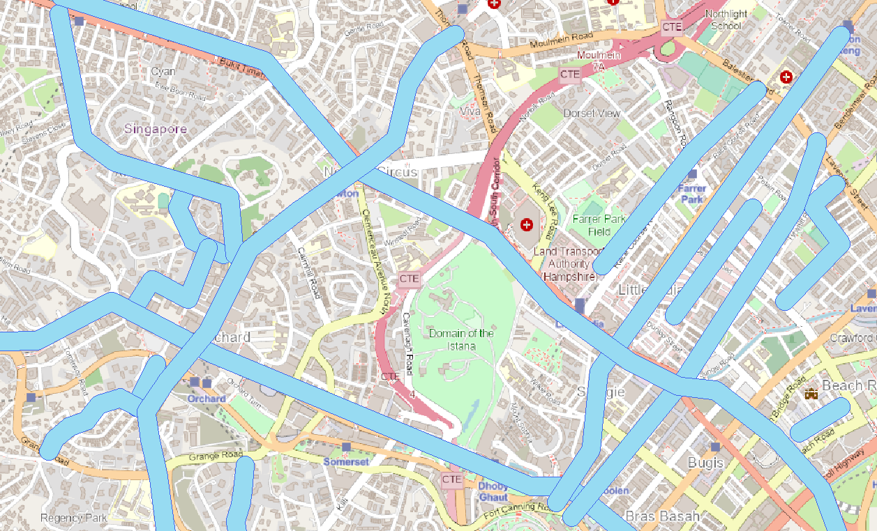

**Figure 8. Example of roads buffer**

* + Create a buffer for **parks** which expand the outside of the park size by **10** m.

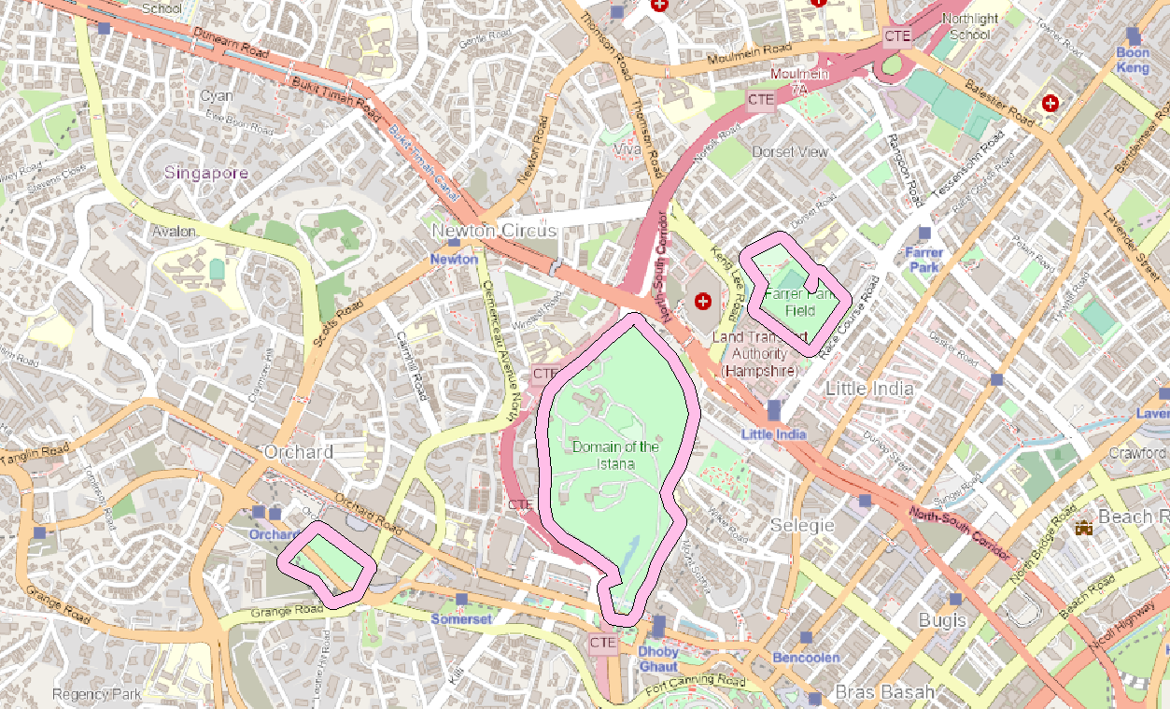

**Figure 8. Example of roads buffer**

* Create an **analysis** of the map:
  + Create an **intersection** that shows all **roads buffer** which intersects with **places buffer**.

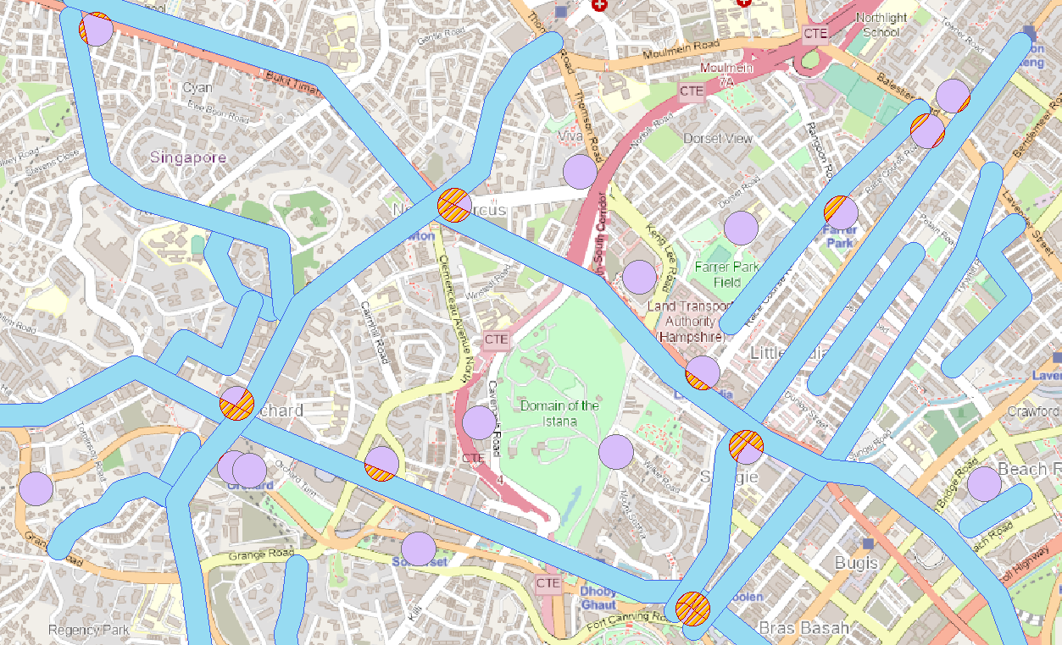 **Figure 10. Example of places buffer intersection with roads buffer**

* + Create **erase** that erase **places buffer** which intersect with **roads buffer**.

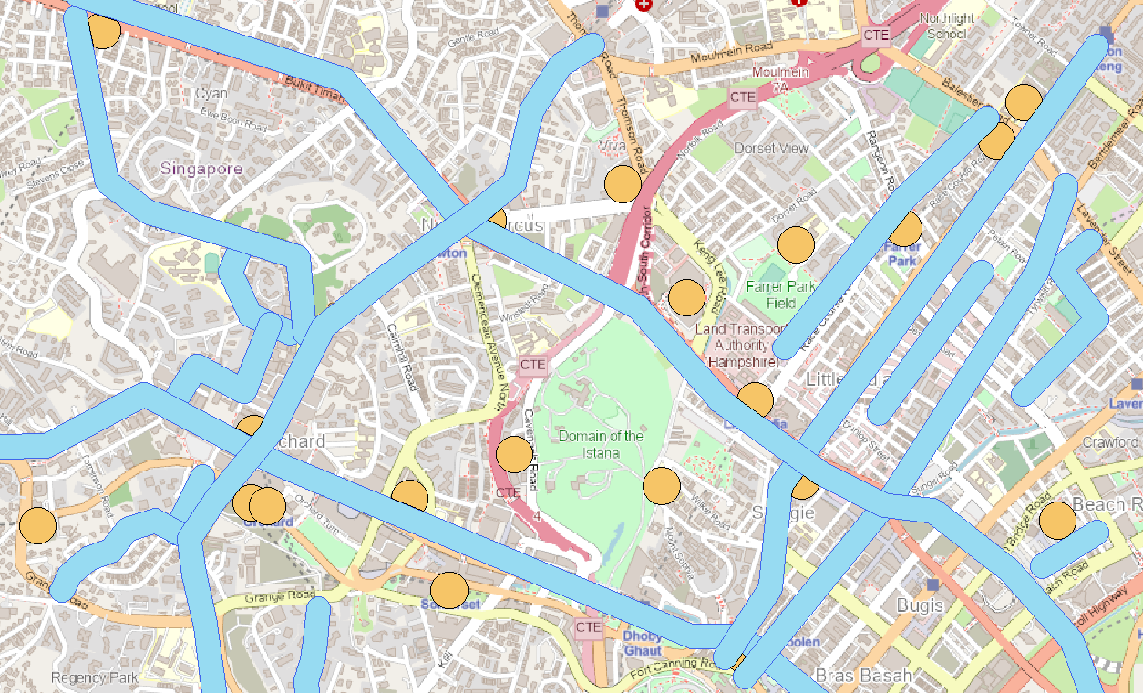

**Figure 11. Example of places buffer erases with roads buffer.**

* Create a map presentation with below requirements:
  + Create a map with **LandscapeModernInset.mxd** layout template to view all of the data required in **Singapore** (**Hospital**, **Mall**, **School**, **Road**,and **Park**).
  + Insert the following components to the map:
  + **Scale Bar**
  + **North Arrow**
  + **Legends**
  + **Coordinate System**

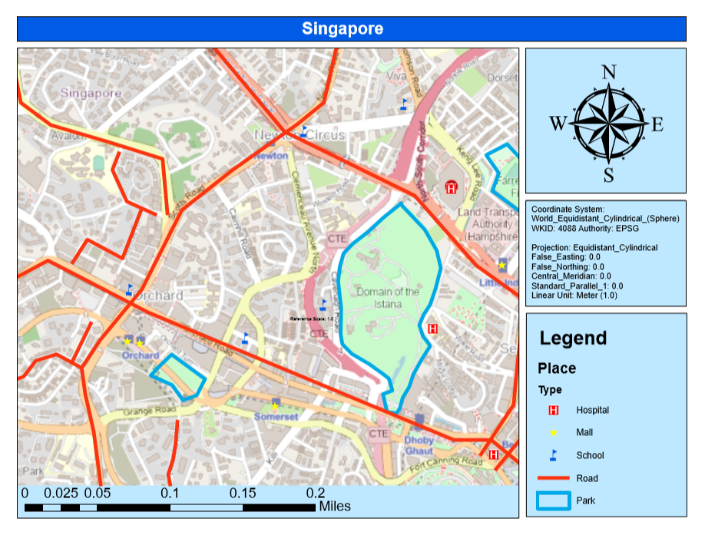

**Figure 12. Example of the exported map**

**Notes**:

* Compress the **Map File** (**.mxd)**, **Geodatabase File** (**.gdb)**, **All of Calculation and Expression Files** (**.cal** and **.exp)** and **Exported Map File** (.**pdf)** in zip and make sure that collected files **can be opened**.
* All formulas in the “field calculator” must be saved into a .cal files.
* Pictures shown above are just an example. The result may be different.